- 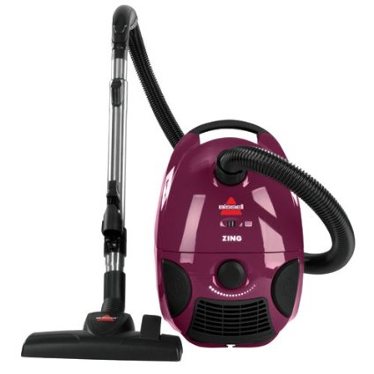

BISSELL Zing Bagged Canister Vacuum, Purple, 4122

Price: | $49.99 & FREE Shipping.
In Stock.
Want it tomorrow, April 7? Order within 10 hrs 32 mins and choose One-Day Shipping at checkout.
Ships from and sold by Amazon.com. Gift-wrap available.
- Powerful suction gets the dirt high and low great for bare floors, rugs and above floor cleaning
- Compact and lightweight for cleaning on the go
- Multi-surface cleaning: easily go from cleaning carpets to hard floors with the flip of a switch
- Includes: Telescoping Wand, Automatic Cord Rewind, Variable Suction Control, Full Bag Indicator
- Please note: When using this unit on carpets make sure you have have the carpet brush engaged on the floor nozzle
- 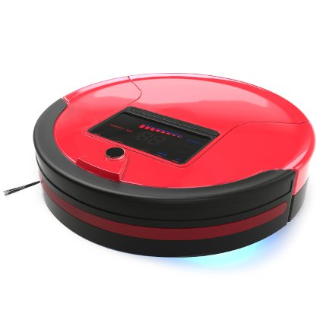

bObsweep PetHair Robotic Vacuum Cleaner and Mop, Rouge

List Price: | $669.00
Price: | $239.00 & FREE Shipping.
You Save: | $430.00 (64%)
In Stock.
Want it tomorrow, April 7? Order within 11 hrs 28 mins and choose One-Day Shipping at checkout.
Ships from and sold by Amazon.com.

Color: Rouge

- Simultaneous sweeping, vacuuming, mopping and UV sterilizing
- Self-Charging
- Programmable Schedule
- Remote Control
- Hepa Filtration

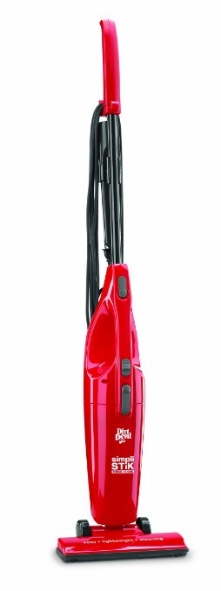

Dirt Devil SD20000RED Simpli-Stik Lightweight Bagless Stick Vacuum - Corded

List Price: | $39.99
Price: | $18.82 & FREE Shipping on orders over $49.
You Save: | $21.17 (53%)
In Stock.
Want it tomorrow, April 7? Order within 10 hrs 57 mins and choose One-Day Shipping at checkout
- 3-in-1 vacuum cleaner functions as a stick vac, handheld vac, and utility vac
- Handheld unit detaches easily from the larger unit; onboard crevice tool
- Simple on/off switch; smooth-rolling wheels; convenient cord wrap
- Lightweight construction for comfortable carrying; removable dust cup
- Measures approximately 7 by 11 by 45 inches
- F25 Filter - 2SV1102000 fits this unit

- 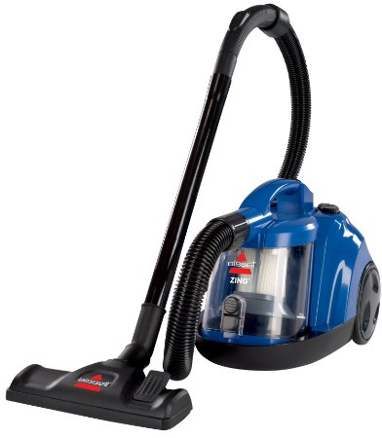

BISSELL Zing Bagless Canister Vacuum, Caribbean Blue

List Price: | $69.99
Price: | $47.99 & FREE Shipping on orders over $49.
You Save: | $22.00 (31%)
In Stock.
Want it tomorrow, April 7? Order within 11 hrs 24 mins and choose One-Day Shipping at checkout.

Color: Caribbean Blue

- Bagless Convenience: Cyclonic action and powerful suction provides thorough cleaning. Plus, no more bags to buy or change EVER
- Multi-Surface Cleaning: Easily go from cleaning carpets to hard floors with the flip of a switch
- Three-Stage Filtration: Dirt cup filters and post-motor filter help to capture more fine dust and particles. Filters are washable and re-usable
- Includes: Easy Empty Dirt Cup, Combination Crevice Tool/Dusting Brush, Automatic Cord Rewind, Air Flow Regulator

- 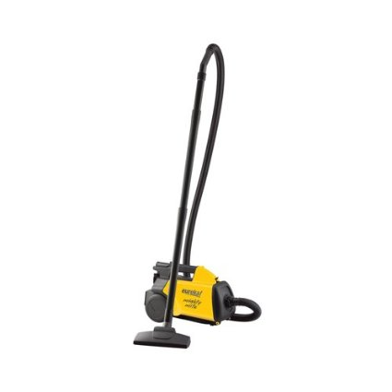
Click to open expanded view

Eureka Mighty Mite Canister Vacuum, 3670G

List Price: | $119.99
Price: | $71.00 & FREE Shipping.
You Save: | $48.99 (41%)
In Stock.
Want it tomorrow, April 7? Order within 9 hrs 50 mins and choose One-Day Shippingat checkout.
Ships from and sold by Amazon.com. Gift-wrap available.

Color: Yellow

- Durable design great for Home, Auto and Garage cleaning
- Power-Touch handle with easy-to-use fingertip controls; deluxe floor brush; bare-floor nozzle
- Additional port allows blowing airflow to shoot leaves and other debris easily
- Lightweight for portability and convenience
- 20' cord and lightweight style for quick and efficient cleaning
- Ideal for Quick and Efficient Cleaning
- Convenient for Home and Auto

